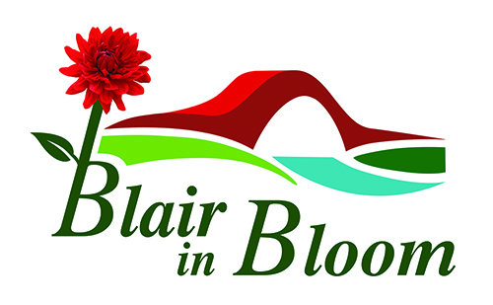

Minutes of Committee Meeting held on

Monday 3rd July 2023

At 4 McLaren Park. Blairgowrie. PH10 6US

1 | Those present: Cathy Doe, Pat Lumsden, Jean Smith, Avril Wilson, William Wilson.
2 | Apologies from: Mary Birch, Cllr Bob Brawn, Morag Reid, Cllr Caroline Shiers.
3. | Minutes of last Meeting. Approved by Jean Smith. Seconded by Pat Lumsden.
4.  5.  6.  7. | Matters Arising:  Bank Signatories: Morag and Jean now both have bank cards and are able to authorise payments  Blueberries: Jean is meeting with Lesley on 4th July and will report back.  Pop Up Shop - Coupar Angus shop not available this year. Pencil in for end of March 2024.  Water Usage at RCG – BRDT expect us to be eligible for 100% rebate on water charges.  Watering Rota for baskets up and running well.  Memorial Shrubs at Coronation Corner now planted and much appreciated by donor. WI sign to be put up.  Mushroom Trust - Visit took place to RCG to view new roof financed by the Trust.  Inventory of equipment to be done including collecting chain saw from Ian Cruickshank.  WI Talk. - Jean and Cathy to attend but still awaiting date.  Treasurer’s Report.  Money in Bank £3230.20 This includes three large deposits. £540 initial deposit from plant sale. £300 donation. £500 Tesco Grant (ringfenced for RCG).  Request from Treasurer that any purchases made should be notified to her in writing, email or What’s App. Also receipts where possible.  A meeting with Monica Straughan was most helpful and a suggestion to have the PKC allowance shown separately was agreed as this would assist in the understanding of the accounts and would be a benefit to all.  Tasks and Priorities List = as attached.  AOB.  Strathmore Centre for Youth Development. (Shaun Donald) keen to be involved at the Community Garden. Further arrangements to be made with regard to helping clearing up at the Garden.  Some discussion then took place with regard to the Community Garden. Concern had been expressed by some Blair in Bloom representatives as to where Blair in Bloom stood with regard to the Garden and the other groups who may be involved in the future. The Minute of Understanding was referred to where Blair ini Bloom’s position is clearly stated with regard to use of polytunnels etc. It was suggested this be available for all to view and that a communication be sent out to volunteers by the Steering Group relating to their plans and hopes for the future of the Garden.  BBC One Show - It was felt we were not yet in a position to take part in such a programme.  Drummond Castle Garden Party – 11th August. Invitations will be sent out for four of the Committee to attend. William was not interested in attending and Cathy was happy not to attend so Avril, Morag, Jean and Pat will be the Committee members to attend.  EGM – Catering - Tea and home baking to be available. Jean to buy coffee, sugar, tea and milk. All the committee to supply either home baking or some contribution. Chairs to be collected Monday morning by William. Jean to bring two further kettles.  A suggested Agenda for EGM was read out and agreed.  Hanging of Baskets - Concern was raised as to the safety of the people hanging the baskets. After some discussion it was agreed to approach Tayside Contracts and TJB for quotes as to the cost of having the baskets hung on our behalf.  New Committee Member: Jan McHugh has been approached and has agreed to join the Committee with effect from September 2023.  Committee Members Roles : Avril volunteered to take on the role of Events Co-ordinator and will oversee the organising of raffles, quiz nights, etc with the help of other volunteers as necessary.  Funding opportunities - Cathy volunteered to investigate Funding opportunities and working with Morag, will bring any of interest to Blair in Bloom to the Committee for their consideration. If assistance is required with appllications Sam Stewart has previously offered her expertise in this area.  Projects in need of funding in 2024  The Meeting Place – Any ideas on how to improve the Meeting Place to be brought to the next meeting for discussion and estimation on costs.  Elm Drive – Roundabout. Bob Brawn to be asked to contact Perth and Kinross Council (Roads Dept) to establish what we have licence to do with the roundabout.  Open Spaces Meeting – 21 July at 10.00am Jean and Cathy to attend  Rotary weekend. 15th July - 10am – 2pm Blair in Bloom have a table at this event to sell plants.  Visit to Victoria Gardens – 8th July AT 11AM.  Problem with Megan’s email address. Avril to investigate.  Date of Next Meeting: Monday 7th August at 6.30pm. Venue to be notified at a later date. | AW  JS  WW  JS  WW/JS  WW  WW  CD/MR  CD  JS/CD  JS/AW/MR/CD  JS/CD/MR/AW  AW

